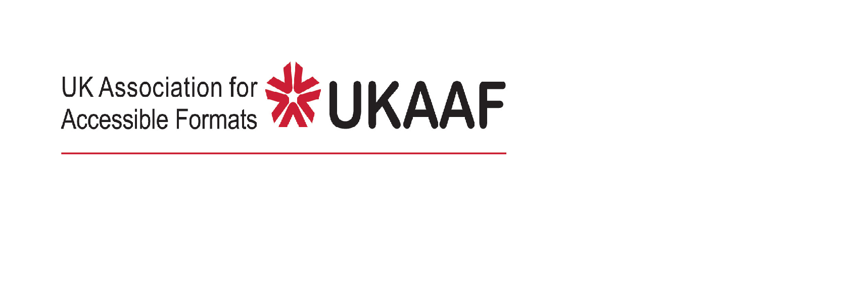

UK Home Nation Languages
as a SECOND LANGUAGE in Braille

This guidance from the UK Association for Accessible Formats (UKAAF) clarifies what to do for English, Welsh and Irish Gaelic when used as second languages in the UK. Other languages, such as Scottish Gaelic, Manx and Cornish do not have an official braille code, so use UEB.

General
UKAAF has published general guidance for dealing with languages other than English, depending on the context, summarised as three "Methods":
- Method 1, English context. When a word or short phrase in another language occurs in English context, use all signs from Unified English Braille (UEB), including the UEB accent signs. Contractions may be used. This is the method for novels, magazine articles and other casual reading material. Similarly, when Welsh and Irish Gaelic are first languages, use UWB and UIB respectively.
- Method 2: Educational context. When learning a language, passages in the language being learned should use the letters and accented letters from the language's braille code, with all other signs (numbers, punctuation, symbols and other braille indicators) still UEB. Contractions are not used. This is the method used in school language textbooks and exams.
- Method 3, Significant knowledge. This is the method used when significant knowledge of the language is assumed. The full braille code from the language being learned is used. Contractions may be used.

It is worth noting that the Unified Welsh Braille (UWB) and Unified Irish Braille (UIB) codes have numbers, punctuation, symbols and other braille indicators aligned to Unified English Braille (UEB).

English
Where English is presented as a second language in educational material, Method 2 equates to using UEB Uncontracted (grade 1). Of course, if a student has learned the full contracted UEB code, the student may opt for UEB contracted (grade 2), which would equate to using Method 3.

Welsh
Where Welsh is presented as a second language in educational material, Method 2 equates to using the UWB uncontracted (grade 1) code.

Note that in Welsh, CH and TH are considered letters of the alphabet and their braille signs are routinely used in uncontracted (grade 1) UWB. Therefore, signs for CH and TH, as well as the accent signs from UWB are used for Method 2.

If a student has learned the full contracted UWB code, they may opt for UWB contracted (grade 2), this equates to using Method 3.

Irish
Where Irish Gaelic is a second language, the accent signs from UIB are used. This equates to using UIB uncontracted (grade 1). If a student has learned the full contracted UIB code, then UIB contracted (grade 2) may be used, equivalent to using Method 3).

Scottish Gaelic
At the time of writing, there is no specific braille code for Scottish Gaelic. Therefore, UEB accent signs are used and no contractions, equating to using UEB uncontracted (grade 1).

Conclusion
In effect, for Home Nation Languages, the UKAAF Methods 2 and 3 effectively equate to using UEB, UWB or UIB uncontracted or contracted respectively. No special exceptions are necessary for Home Nation Languages.

[November 2025]

UKAAF contact details
Tel: 01270 449165
Email: enquiries@ukaaf.org
Web: www.ukaaf.org

President: Lord Low of Dalston CBE
Registered charity number: 1126966

Registered as a company in England and Wales number: 6748900

