

UKAAF webinar, 21 March 2024

The Curious Case of Barbier and Braille

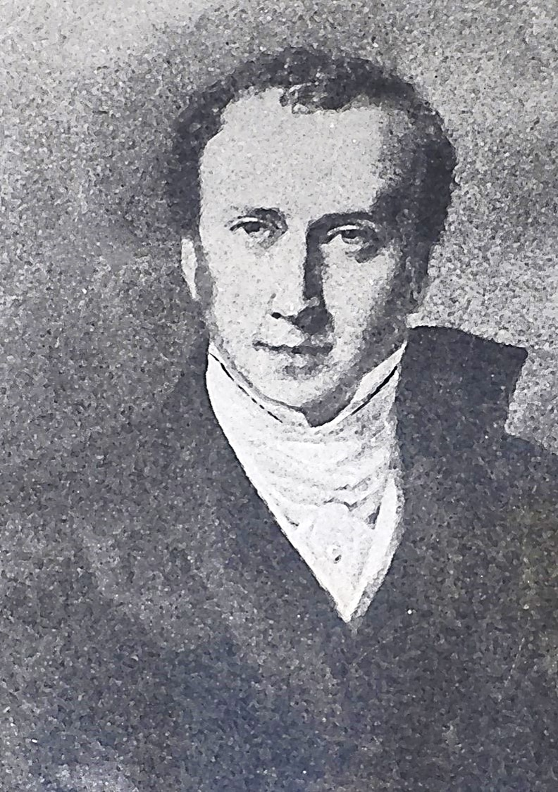

Hello, and welcome to this UKAAF webinar, “The Curious Case of Barbier and Braille”, particularly if this is your first time with us.

My name is Roger Firman, and we are delighted to be joined from Toronto by today’s guest, Phillipa Campsie, welcome.

Philippa, I wonder if you would like to tell us about yourself.

Philippa
Well, right now I’m retired. I retired after two separate careers, first I worked in publishing and then I took a Graduate Degree in urban planning working as a freelance researcher on urban issues for the rest of my career. The work I’ve done on Braille and Barbier is not exactly in the field that I studied for although I do have an Undergraduate degree in history, and I’ve always been fascinated by history, but this is quite a new departure for me.

Roger
What was the inspiration leading you to research Charles Barbier and Louis Braille?

Philippa
Well, my interest began in 2016 when my husband and I were in Paris. My husband is an historian of technology, something quite unusual, and he had become extremely interested in technology of communication with, and among blind people, they have a museum in Paris. there is the big school, the National Institute for Young Blind, for school-age children (Institut national des jeunes aveugles, INJA); next door there is the Association Valentin Haüy, which is a training school for adult blind people, and in that building, there is a museum, library and archive. So my husband was there looking at these interesting and varied machines designed to help blind people communicate with each other or sighted people. and I was just looking around at books and displays and found something interesting. I learned that although braille is named for Louis Braille, he was not the inventor of the idea of communicating with raised dots, and did not attempt to reproduce the shapes of the letters of the alphabet, and he did not invent the tools for doing this, that was somebody else called Charles Barbier.

There was just a very little bit about Barbier in the museum, and I looked at one of the books, and it also seemed little was known about him or his background, so I went to the curator of the museum and I said “what do you know about Barbier?” and she said “are you interested?” and I said “well I’ve only just seen the name for the very first time but it is clear he is very important in the history of the creation of braille, and she said “we have his papers here”.

His family donated his papers to the museum in about 2001 and she said, “I’ve catalogued them and created a little inventory of what’s in there but nobody’s ever looked at them or read them or used them for research, would you like to see them?” I thought, well, here I am, and nobody else seems to be doing this, and my husband is busy, so why didn't I take a look, I was just curious. I didn't have anything in mind. I didn't know what I might find or what I would do with anything I did find. I was just curious because it seemed that not much was known about him.

So, while I was there, we went back a couple of times to the museum, I photocopied and photographed things and took it all home with me to Canada and started to work my way through it, and used other resources to fill in some of the blanks. What I discovered is that the story of the invention of braille, as it is usually told, is full of errors and myths. So that's when I started to write about Barbier and Braille and ended up publishing an article.

Roger
Could you say something about the sources you have used?

Philippa
Well, I was very lucky that I was doing this when I was doing it. Books have been published about Braille, and they include Barbier. But when they were published, the resources that I had available weren't generally available. So, the first thing was the books and papers donated to the museum, that was my first resource. But I also discovered that in the library of the school, there was also a big file of correspondence, and so I was able to use that as well. The wonderful thing about that was the materials given by Barbier's family were mainly letters that had been written to Barbier, whereas what was in the archives at the school were letters that had been written by Barbier to people at the school, including Braille himself, but also the Director of the school. And in some cases, we have both sides of the correspondence, which was wonderful.

I also made a couple of trips to Coupvray, which is a small town, the birthplace of Louis Braille. It's about twenty miles to the east of Paris, so you can get there on a commuter train, and they had some resources that I hadn't seen elsewhere.

I also had all the resources of the Internet, and I was able to find all kinds of things that would not have been available to earlier researchers. Some of Barbier's books, the ones he wrote, are now available as Google Books, for example, but I was able to find all kinds of other things. Barbier, as a young man spent time in the United States, for example, and the first thing I found was in the online documents of the Library of Congress, he had written to none other than George Washington when he arrived in the United States, and that letter is conserved and is available online. After a few years in the United States, he moved to Kentucky, and there's a Kentucky newspaper dating from the late 18th, early 19th century in which Barbier placed some ads looking for a job and then doing various pieces of work. And that was all available.

I didn't go to Kentucky myself, but I asked a researcher to find some documents for me in the Kentucky archives, the finding aid to some of the papers was online, and so I knew exactly what I wanted. I just hired somebody down there to photocopy some papers and send them to me. And so, there were a huge number of resources that I hadn't been aware of when I started. The other thing is that The National Library of France (The Bibliothèque nationale de France), has an amazing online presence. And you can research all kinds of things and read out of print books, see documents, see newspapers and find out things that way. So really until now, a lot of the materials that I used just weren't available to previous researchers.

Roger
I know you have spent some time in Paris in late 2023 and early 2024, what new insights did you gain?

Philippa
Well, the funny thing is that at the moment the association Valentin Haüy is temporarily closed, they had to do major renovations to the building, I think to remove some asbestos from the building. So, the museum is closed, but they did have archives of the school which I'd seen before. But oddly enough, when I opened the box that I thought I knew everything that was in there, and I'd taken notes, there was a new document I'd never seen before which surprised me, it was something completely new. It was poster sized, you had to fold it out. It's like four A4 pieces of paper put together in a poster sized document, and it described Barbier's method. But what was unusual about it was that it was not something published by Barbier, but by somebody else.

Perhaps I should explain the Barbier method here. Barbier in 1815 had published a book with a new approach to communication for a variety of different people, which included not just people who are blind, but people who are deaf, or people who had no formal education. He wanted to create simplified forms of writing for all sorts of people who at that time had difficulty writing or did not have access to formal education to learn conventional writing. All of these methods were based on the same approach, which was a grid. So, if you can imagine a grid of five by five forming twenty-five squares, five across, five down. And in these squares, he placed the letters of the alphabet. Now you're saying to yourself, but there are twenty-six letters in the alphabet. Well, actually at the time he's writing in the early 19th century, the letter “W” was not in the French alphabet. It was used for proper names, There were place names and people's names that began with “W”, but it was not a formal part of the alphabet. So, the French alphabet fitted perfectly into this twenty-five by twenty-five grid.

He also had another grid which was simply phonetic, starting with the vowels and then the consonants, and that the sounds took up a grid of five by six. Anyway, the point of the grid was to turn each letter or sound into a two-digit number with one representing the row number, and one representing the column number. So, “A” obviously was one, one, first row, first column, all the way down to “Z” which was five, five, fifth row, fifth column. By creating symbols to represent these numbers, you could write in a number of ways. It could Also be used for sign language. If the fingers of your left hand represented the row number and the fingers of your right hand represented the column number and the thumb was number one, then touching your two thumbs together would form the letter “A” for example, or touching your two baby fingers together would form the letter “Z” and all the letters in between. So, he created more than a dozen different ways of writing using these grids that transferred letters or sounds into two-digit numbers. And then there were ways of representing those numbers. And what he created for blind people was simply two vertical rows of dots, and the number of dots on the left-hand side represented the row number, and the number of dots on the right-hand side represented the column number. And he also invented and illustrated in the book, the tools, which were a long piece of wood with six grooves in it. You'd place the paper over that, you'd use a blunt punch to create dots in the paper, and there was a little metal piece that helped you to line up the dots vertically if you couldn't see what you were doing. So that is the method. And he published the book in 1815. But there were also different publications in which he put forward his ideas.

What I found last December was a description of all this, but it was not done by Barbier himself. It had been done by a group based at what's known as the Quinze-Vingts. The Quinze-Vingts stands for twenty by fifteen. It's a facility that was created in Paris in the Middle Ages in the 13th century, and it sheltered three-hundred people who were blind, or the people and their families, so that was a place where blind people lived. Some of them were able to earn money. Some of them just used it as a roof over their heads and earned money by begging in the streets. Most of them had very little education, some of them were trained in a few skills. Later it became a little more sophisticated and they had developed a music program.

Anyway, this document showed the method that Barbier had created, but it had actually added to it because Barbier's method, unlike Braille's - and this was one of the huge improvements that Braille introduced - it had no punctuation and at first, no numbers. You couldn't use it for music or anything else, or all the other ways in which braille is now used. But the people at the Quinze-Vingts had created punctuation. Although it wasn't on that particular poster, I knew that they had created numbers, just integers. They didn't have mathematical symbols or anything, but they had added to this system, and they were using it. And so, the very first time I went into the archives, I saw this and looked at them and I thought, oh my goodness, they've created punctuation here. They've created a new description of the method. And then my last visit to the archives before returning to Canada, I was walking around looking at some books that were on the shelves and I picked one up and looked at it and I said, “oh, this is interesting. This book has been published using Barbier's system.” Up to that point there were two known books published using Barbier's system, so now we know there were three. Presumably, this also came from the Quinze-Vingts. They had created these books using Barbier's system, and since most of the people at the Quinze-Vingts had very little education, they used it in its phonetic form, and they had published at least three books, three books that have survived as well as this poster describing the system. So, I realised I needed to know a lot more about the Quinze-Vingts and the people who were there. I was able to do some research on the people whose names appeared on the poster, but I had not up until that point realised that these people in this hospice which was completely the other side of town from the school, were using it and creating books in it and even adding to it. So that was quite an exciting discovery to make.

Roger
To date, are there any things which have surprised you whilst on this research journey?

Philippa
Almost everything surprised me. The main thing that surprised me is all the errors. When I first started reading the documents, I went to the Wikipedia article, and I looked at some background and read a book. There are several books, one produced in the 1950s by a French historian called Pierre Henri, which was created around the time of the centenary of Braille's death, when his remains were transferred to the Panthéon, and there was quite a lot of interest in his story, and a more recent book published in English and French by a historian called Michael Mellor. They all told much the same story about Barbier and Braille, but there were also a lot of other children's books.

I mean that Mellor and Henri were writing for grown-ups but there were a lot of children's books and little videos on YouTube and they told a cartoonish version of the story that was based entirely on fiction as far as I can tell. And so, at first it took me - there was a sort of cognitive dissonance - that wait a minute, wait a minute. This, the correspondence that I'm reading, these original books that I'm reading, this material that comes from the early 19th century, it tells a different story. It took me a while to realise, well, obviously the original documents are correct and all of these other versions from Pierre Henri and other people are wrong. So, as I cleared away some of the misunderstandings, I had to go in search of where they had come from. Why was it that people had got hold of the wrong story? and they were telling a fictional story, I'll give you some examples.

In all the versions that I have seen, there is a meeting between Barbier and Braille. It's usually shown that Barbier came to the school to introduce his method and at some point, he encountered Braille. And this meeting, supposedly, takes place in about 1821, which was the point at which the school started using Barbier's method. It's depicted as a rather hostile encounter between a very young Braille, who in 1821 was only twelve years old, and a much older Barbier. He was about forty years older than Braille and would have been in his fifties at the time. And Braille is questioning the validity and usefulness of his method. He's pointing out that, pointing out presumably things like, it doesn't have punctuation, it doesn't have numbers, and that you can't use it for music, and also it takes up too much room, the length of the row might be as much as six dots down.

Unfortunately, this encounter never took place. The correspondence makes it very clear that Barbier, for one thing, never came to the school. One of the great things for a researcher is that he wrote everything down and it's all in correspondence. He probably visited the school once or twice and met the Director. But the beginning of the use of Barbier's raised dot system at the school in Paris was all done by correspondence. Barbier sent letters to the Director, he sent his versions of his tools. He sent a great number of tools to the school so that the students could learn his method, but it was all done at one remove. It was not done in person. Therefore, we have a record of when he corresponded with the Director. The Director writes back, saying, we've had a demonstration of your method, and it was successful. The demonstration was very simple. The materials and tools were given to at least two students, and the students demonstrated it before what was called Le conseil d'administration, which is similar to a Board of Governors. The two students would be in the room and then one student would be sent to a distant room. The one who was left would take dictation using the method. One of the governors would just pick a book at random and read out a couple of sentences and the student took notes, writing as you do with braille from right to left. Then they would bring the other student back, turn the paper over, and the student successfully read out what was written on the paper. And we have actually several letters, not only from the Director of the school but from the Head of the Board of Governors saying the demonstration was successful, the students can use this method.

So, because of all the correspondence, it's very clear Barbier was not there when it was demonstrated. He did not himself teach it to the students, he got to hear about it a day or so later. So, the meeting with Barbier and Braille, we know that didn't take place because there are letters dating from 1833 between Barbier and Braille, and there's nothing before then. And what happens in 1833? So, this is many years later. Braille is now an adult and he's already published his own system, the first iteration of his system, in 1829. This is four years later. Barbier's still in touch with people at the school. He learns that a new system is available and is being used at the school. He asks to see the book in which it is published. He reads it and he writes to Braille to congratulate him. He says this is a great idea, this is excellent, what you've done, being Barbier - and because he's so insistent upon universal education - in the letter, he says, oh, you could also make a phonetic version, you know, but which Braille of course ignores. But he realised that there's a whole series of letters between the two of them, and it's clear from the letters that Braille comes to visit Barbier. Barbier, by that time is getting on and doesn't leave home a lot. Braille comes with a friend to visit. They have a cordial exchange. There's a big difference in their age, so they don't exactly become best friends, but they have a cordial and pleasant relationship, and this is not reflected in any of the books about Barbier and Braille. Instead, we have this fictitious encounter between Barbier and Braille when Braille is very young, and it's been dramatised over and over, that Barbier came to the school, Braille had the nerve to criticise his system, Barbier gets very angry and stalks off. Never happened.

So, I had to find out. Well, why does everybody say it happened? And I found the answer in a book by the man who had been the Director of the school at the time the Barbier system was introduced. His name was Alexandre-René Pignier. He was forced into retirement before he was ready to retire in the 1840s. So, in retirement, he writes a history of the school, and he writes a biographical sketch of Braille. Actually, he writes three of them, about three former students at the school, all of them blind, who went on to become instructors and teachers at the school. And Braille was one of them, and he's the one who invents this little episode. He's writing in the late 1850s. By this time, both Braille and Barbier are dead, and they cannot contradict him. And he creates this little encounter. He doesn't describe it in any detail, he doesn't say whether or not they met in person, and he doesn't describe Barbier's response. He simply says that Braille was very bright and pointed out to Monsieur Barbier some of the problems with his system and suggested little improvements.

So, this is done. He writes this knowing he cannot be contradicted, but to make Braille seem more of a prodigy, to make him seem, at the age of this very, very young age and they've just started using this point writing, which allows them to take notes, which of course they could not do before. And he's already finding something, pointing out the flaws in the system and suggesting ways in which it could be better. So that's complete fiction. And the original correspondence shows that it's complete fiction. And it's one of the many errors and myths that have entered the story. I was surprised to find these frequently repeated stories complete fiction.

Roger
Do you have plans to make available your research?

Philippa
Yes, I've published one article in a journal, it's called the Disability Studies Quarterly. It's published in Ohio, in the United States, and it's available free online to anybody who wants to read it:
https://dsq-sds.org/index.php/dsq/article/view/7499/5947

Currently I'm working on a book, and I started by putting down everything that I had learned about Braille and Barbier in a sort of biography. And then I realised, well, this is very dull to read. It doesn't indicate all the fun that I had doing this research and all the places I went and all the people I spoke to. So now what I am writing is that story.

I'm tentatively titling it “The Search for Charles Barbier and the invention of Braille” or something like that. And I am writing it as I discovered various pieces and the surprises I had and how I was able to trace some of the myths and errors back to their sources. And I think that's a more interesting story, the story of finding out what was happening rather than just what I found out. What I found out would be interesting to academics, but I want to write something that's going to be more interesting to a wider audience.

Roger
In closing, may I thank you Philippa for spending time with us and sharing your discoveries helping us to better understand this subject. From all of us, goodbye until next time.

